BEREAN BAPTIST BIBLE COLLEGE & SEMINARY
72 Wellington Street, Richmond Town, Bangalore 560025 INDIA
Email: chelliedwin@hotmail.com Website: www.bereanbaptistbiblecollege.com

September/October/November 2018
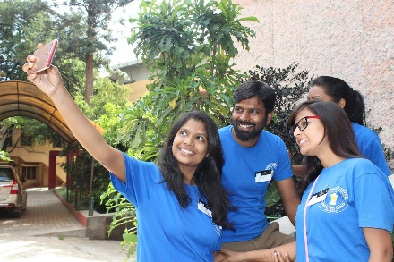

Give Thanks – Praise God

Praise the Lord for freedom to share the gospel of Jesus Christ. The Lord opens many doors to share His wonderful gift of salvation.

Thank you for your support for the opportunities we have to sow seeds of truth and goodness for Christ:

- Bible College training
- Church Planting
- Children’s Homes
- Printing ministry
- Jail ministry
- Schools
- Church services
- Pastors’ Conference
- Christmas programs
- Geriatric Health Care Course
- Pre-School

Church Youth Retreat
October 2018

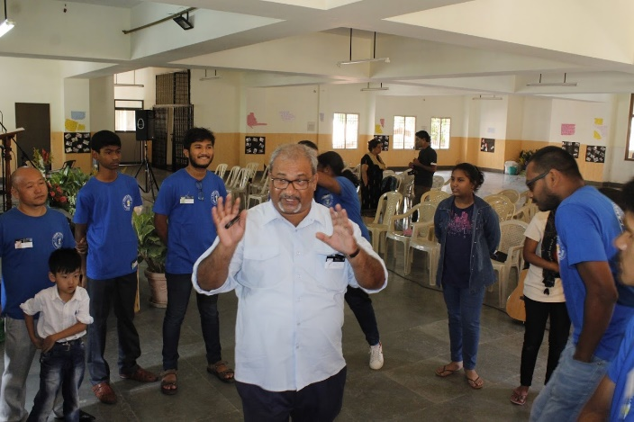

Printing Ministry

The printing ministry of the Bible College has been quiet for some time now. Prayers have been said, direction from the Lord has been sought…and through it all God has said don’t give up…wait for my timing. The Lord has directed us to a project that if given the license to print could be the rejuvenation we have been seeking. Please pray with us that the license to print will be granted and funds for machine repairs, labor, paper, ink and many other expenses will be provided.

But seek ye first the kingdom of God, and his righteousness; and all these. things shall be added unto you. Matt 6:33
Send support for these needs to:
Global Baptist Mission - 8140 Union Chapel Road - Indianapolis IN 46240

