BEREAN BAPTIST BIBLE COLLEGE & SEMINARY
72 Wellington Street, Richmond Town, Bangalore 560025 INDIA
Email: chelliedwin@hotmail.com Website: www.bereanbaptistbiblecollege.com

March 2017
56th Bible College Graduation

By God’s grace, 89 students graduated on March 4th.

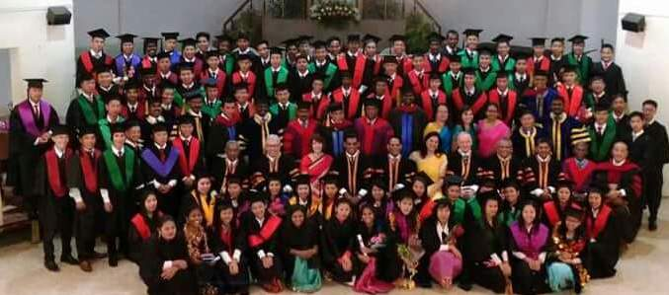

“made strong by the hands of the mighty God of Jacob” Genesis 49:24

“Go ye therefore, and teach all nations, baptizing them in the name of the Father, and of the Son, and of the Holy Ghost” Matt 28:19

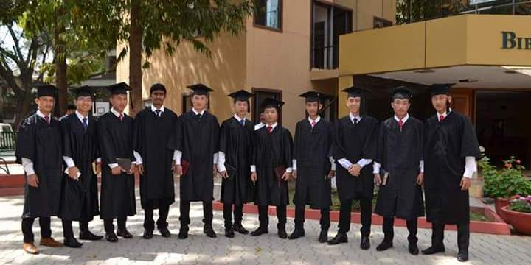

Thank you for your prayers and support of the training of
church planters, evangelists, teachers, and soul winners.

Support address: Global Baptist Mission - 8140 Union Chapel Road - Indianapolis IN 46240

